#### GUIDE TO HEALTHY EATING:

# Nutritional recommendations and ideas for action

**This tool is for:**

The person responsible for implementing good practices for health and quality of life at work.

**Objectives of the tool:**

Outline current nutritional recommendations in certain countries; offer ideas for actions to implement in the company to promote healthy eating.



**Diet is both a risk factor and a protective factor for many diseases.** The development of different chronic diseases can be reduced by following official nutritional recommendations, and eating an adequate diet can help us take care of our mental health.

Given that employees spend a large part of their time at work, the workplace is a natural setting for increasing their awareness by putting in place prevention policies for healthy eating. Being concerned about healthy eating in the workplace offers a range of benefits to the company:

* Development of well-being and creation of a healthy and positive work environment
* Reduction of health care costs and enhancement of employees’ health capital
* Increased employee motivation and performance

**This tool outlines the nutritional recommendations of several countries. Several ideas for actions to put in place within the company to encourage employees to follow these recommendations are also suggested.**

#### NUTRITIONAL RECOMMENDATIONS – AN INTERNATIONAL SNAPSHOT

In Canada

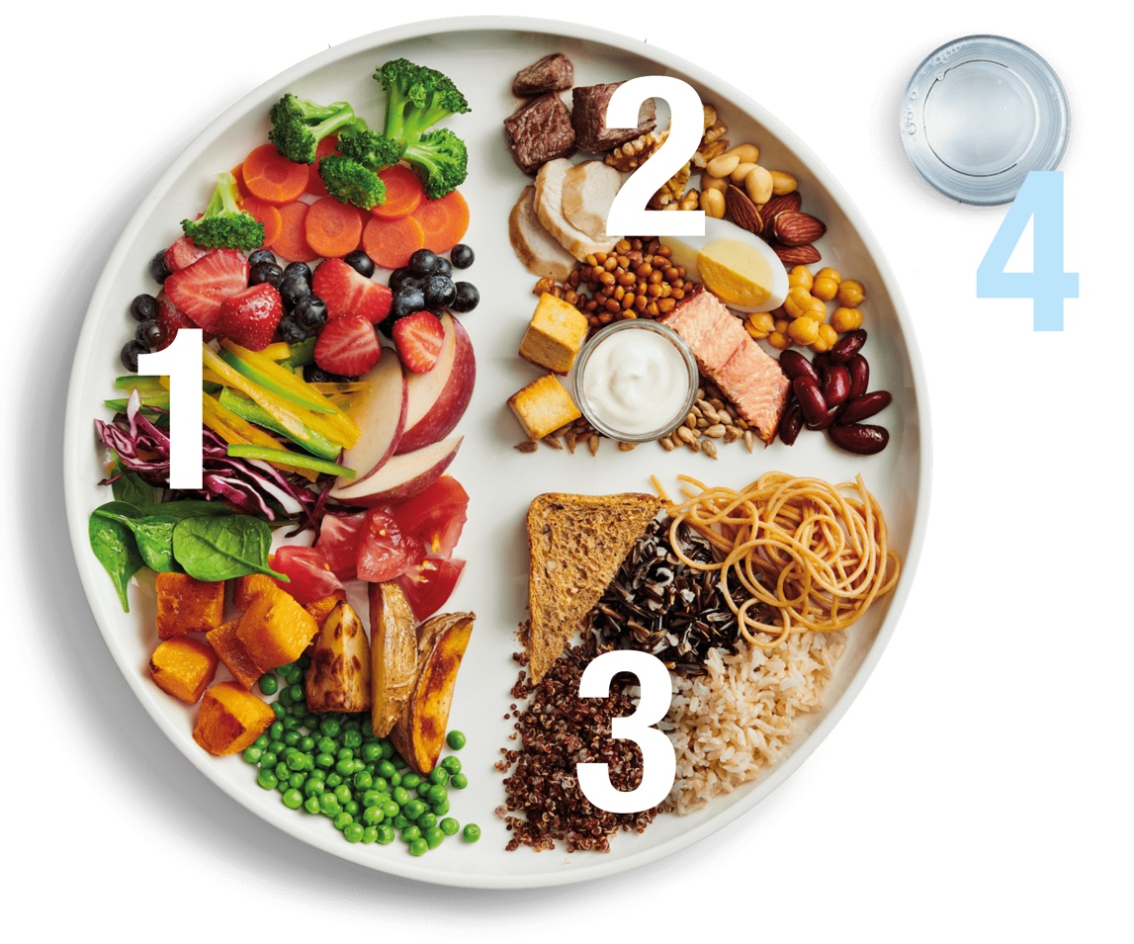Recommendations for healthy eating are available in [Canada’s Food Guide](https://food-guide.canada.ca/en/), produced by Health Canada. This guide contains advice on foods to prioritize and good eating habits. It is believed that healthy eating goes beyond the foods we eat: it also involves how, where, when and why we eat.

### Eat a variety of healthy foods every day:

1. **Have plenty of vegetables and fruits**
2. **Eat protein foods**, and choose plant-based sources more often: eggs, lean meats and poultry, fish and seafood, legumes, nuts and seeds
3. **Choose whole-grain foods** for their high fibre and rich vitamin and mineral content (quinoa, whole-grain bread, whole-grain pasta, whole-grain brown or wild rice, etc.)
4. **Make water your drink of choice** and limit sugary drinks

### Healthy eating is much more than the foods you eat:

* **Be aware of your eating habits:** that is, be mindful of the time, place, reason and quantity as well as what you eat. This allows you to make healthier choices more often, which brings positive changes to your usual eating habits and allows you to reconnect with the experience of eating while creating awareness of your thoughts, emotions, sensations and behaviours.
* **Cook more often:** cooking at home allows you to choose your ingredients and control the quantity of ingredients (sauce, salt, seasoning, etc.), depend less on highly processed foods and learn new skills.
* **Enjoy food and enhance the pleasure of eating.**
* **Eat your meals with others:** sharing health foods with family, friends, neighbours or colleagues is an excellent way to create or strengthen social connections while making life enjoyable.
* **Read food labels:** they provide useful information for making informed choices of foods and drinks at the grocery store and at home.
* **Limit your consumption of highly processed foods:** they contain too much sodium, sugar and/or saturated fat.
* **Be vigilant about food marketing:** it can influence your food choices.

In France

In France, dietary recommendations are combined with those for physical activity and sedentariness. They are available on the official website [Manger Bouger](https://www.mangerbouger.fr/l-essentiel/les-recommandations-sur-l-alimentation-l-activite-physique-et-la-sedentarite) [Eat Move] and are summarized in [an infographic from France’s public health department](https://www.santepubliquefrance.fr/determinants-de-sante/nutrition-et-activite-physique/documents/infographie/les-recommandations-sur-l-alimentation-l-activite-physique-et-la-sedentarite-en-un-coup-d-oeil).

Revised in 2019, these new recommendations aim to cover overall nutritional needs, prevent chronic illness and minimize exposure to contaminants in food while trying to remain relatively close to current food consumption habits to make the recommendations easier to adopt. The impact of food on the environment is also considered.

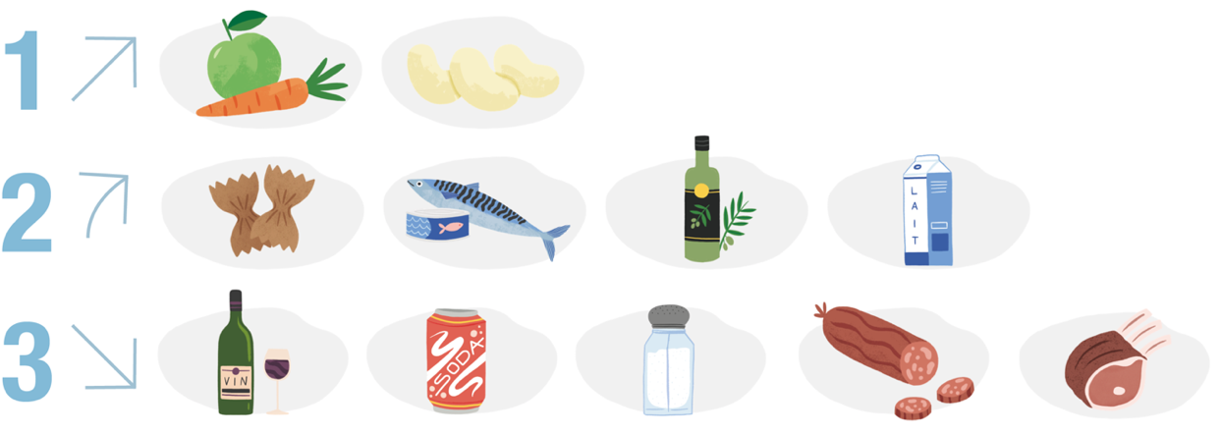**Dietary recommendations for adults are divided into 3 main parts:**

|  |  |  |
| --- | --- | --- |
| **1. INCREASE:**   * **Fruits and vegetables:** at least 5 servings of fruits and vegetables per day (1 serving = 80 to 100 g, which equals the size of a fist or two heaping tablespoons) * **Legumes** (lentils, kidney beans, chickpeas, etc.): at least twice a week for their high fibre content | **2. MOVE TOWARD:**   * **Whole grains:** at least  1 whole grain per day for their high fibre content * **Fish:** twice a week, including a fatty fish (sardine, mackerel, herring, salmon) * **Canola, nut and olive oil** * **Dairy products** (milk, yogurt, cheese and cottage cheese): twice a day for adults | **3. REDUCE:**   * **Alcohol:** maximum  2 glasses per day and not every day * **Sugary drinks**, sweetened products and ultra-processed products * **Salt** and salted products * **Deli meats:** limit to 150 g per week * **Meat:** opt for poultry and limit other meats (pork, beef, veal, mutton, lamb, organ meats) to 500 g per week |

In Belgium

The Conseil Supérieur de la Santé (Superior Health Council, or CSS) created a set of guidelines titled *Food Based Dietary Guidelines*(*FBDG*) that outline the priorities for nutritional choices that contribute to maintaining and promoting the health of Belgian adults. These recommendations are summarized in a short video. Also, a tool called [**L’Épi Alimentaire**](https://www.foodinaction.com/epi-alimentaire-priorites-mieux-manger/) shows, in ascending order, the 5 main nutrition priorities that are linked to the greatest health benefits*.* In addition to giving recommended amounts, these recommendations take into account knowledge of the links between food and health as well as aspects of sustainable development.

### 5 priorities for healthier eating

1. **Whole-grain products** (whole-grain bread, brown rice, whole-grain pasta, bulgur, quinoa, etc.):

* At least 125 g per day
* Replace refined grains with whole grains (e.g., choose whole-grain bread over white bread, whole-grain pasta over white pasta)

1. **Fruits and vegetables**: look for variety while being guided by what’s in season and local

* Fruits: 250 g per day (2 fruits): fresh, frozen, stewed without sugar, canned without added sugar or freeze-dried
* Vegetables: 300 g per day (over several meals): fresh, frozen or freeze-dried/dehydrated

1. **Legumes** (chickpeas, lentils, white beans, etc.):

* At least once a week: fresh, dried, frozen, canned or puréed
* Replace meat at least once a week with legumes

1. **Nuts and seeds**(hazelnuts, almonds, cashews, etc.):15 to 25 g per day (enough to fit in the palm of your hand), uncoated, unsweetened and unsalted
2. **Salt**:

* Limit salt in cooking and do not add salt at the table
* Limit ultra-processed foods, prepared foods, processed meats, salty snacks, sauces, spice blends that are high in salt

### Other recommendations from the CSS: 5 to 12 priorities

* **Milk and dairy products:** 250 to 500 mL per day.
* **Fish and shellfish:** Once or twice a week, including fatty fish once a week. Choose sustainable products that are rich in omega-3 fatty acids.
* **Meat:** Limit consumption of red meat to no more than 300 g per week. Replace it with legumes, fish, poultry, eggs or other substitutes.
* **Processed meats (deli meats, prepared meats, etc.):** Limit consumption to 30 g per week. Replace deli meats with canned fish, side dishes made from legumes, fruit or cottage cheese.
* **Drinks:** Water is the only essential drink. Avoid consuming drinks that contain added sugar (pop, fruit nectars, etc.).
* **Calcium:** Be sure to get enough calcium (950 mg/day) from various natural sources, including milk and dairy products.
* **Fats:**
* Make sure to get enough polyunsaturated fats (such as omega-3) by choosing canola, soy and nut oils and eating nuts and seeds.
* Replace hard margarines and butter with non-tropical oils, spreadable fats and liquid cooking fats.

## Tips and tricks / Ideas for action

Here is a list of possible actions to put in place in your company, based on your needs and resources, aimed at doing prevention with your employees and helping them follow these nutritional recommendations.

**WORKPLACES ARE IDEAL SETTINGS FOR PROMOTING HEALTHY EATING!**

### Create an environment that supports healthy eating in the workplace

* Make sure the cafeteria offers balanced, adequate menus for employees’ needs.
* Create and post a list of restaurants and stores offering balanced meals near the workplace or in certain neighbourhoods for remote workers.
* Make clean and pleasant eating areas available to employees. Purchase equipment, such as a refrigerator and a microwave, so they can bring meals they made at home.
* Stock vending machines with healthy choices (ready-to-eat fruits and vegetables, cereal bars, nuts, yogurt, etc.).
* Install water fountains for employees.
* Offer healthy food choices at meetings and other events. Keep in mind employees’ various diets. Emphasize raw foods and limit ultra-processed foods.,

### Inform and educate employees about healthy eating

* Share with employees the documents on prevention that are available in this thematic dossier and brochures containing official nutritional recommendations.
* Put up awareness and information posters on these topics in the office or in workspaces.
* Invite subject experts to the workplace to implement themed activities (presentations, workshops, cooking classes, etc.).
* Organize potluck meals to talk about employees’ tips and tricks for balancing their diet at work. This type of activity can also be adapted to be done online.
* Give employees the opportunity to share healthy recipes online, by email or in displays.
* Organize themed months or weeks with “challenges / goals” within teams or between services and share the results, such as:
  + Choose a vegetarian option instead of meat at least once a week
  + Take at least 30 minutes to enjoy your lunch every day
* Pay special attention to employees who are working remotely: make them aware of the benefits of meal breaks, of taking their time to eat and enjoy a meal, of preparing meals ahead of time and of the negative effects of snacking on health.
* Certain occupations require nutritional adaptations (night shifts, physical labour or work in specific conditions, etc.). You may need to offer information and direct these workers to consult health professionals.
* Identify resource persons to whom employees can turn if they have questions about these topics of if they need special support (e.g., dietician, local public services, workplace nurses, various associations or organizations in the field of healthy eating).

## Conclusion on nutritional recommendations and useful links

Although recommendations vary from country to country, especially when it comes to food quantities and frequency of eating certain foods, we can see that some key points are similar and therefore seem to be essential for good health.

### 3 highlights:

1. **Embrace the concept of healthy eating:** The links between diet and health are increasingly known and are now an integral aspect of nutritional recommendations.
2. **Prioritize vegetables:** Foods that are high in fibre (fruit, vegetables, legumes, whole-grain products) are at the top of the recommendations. Also, guidelines for animal products are scaled down, with limits on the amount of red meat and deli meats to be consumed.
3. **Limit processed products:** Special attention is given to these types of products, which are very popular and are widely available. Eating them increases intake of salt, sugar and poor-quality fats which, in turn, can increase the risk of chronic diseases. It is recommended that people opt for home cooking instead!

**Finally, eating well also means taking pleasure in eating and enjoying meals, choosing variety and homemade foods, and watching the amounts you eat!**

**To take care of both your physical and mental health, good nutrition is essential, but other elements are also important to keep in mind, such as: do regular physical activity and stay active, make sure you get good-quality sleep, take care of yourself and reduce sources of negative stress, maintain your social network, avoid alcohol, tobacco and drugs, etc.**

**If you would like to learn more about nutrition and related topics, we invite you to   
consult:**

* The tool **Promoting healthy eating at work:** Status report, definitions and presentation of the links between food, physical and mental health, and well-being in the workplace.
* The **5 themed fact sheets for your employees** to inform and equip them to improve their eating habits on the following topics: nutrition and psychological health, ultra-processed foods, fibre, fat and protein.
* The **complementary tool on physical activity**.

### A few links to explore further:

* Canada’s Food Guide, which contains recipe ideas and explanations of the recommendations: <https://food-guide.canada.ca/en>
* Infographic of recommendations for a more balanced lifestyle – Santé publique France [in French]: <https://www.mangerbouger.fr/content/show/1502/file/Affiche_recommandations_adultes.pdf>
* Manger Bouger [Eat Move], which presents recommendations for eating better and moving more in France [in French]: [https://www.mangerbouger.fr](https://www.mangerbouger.fr/)
* La Fabrique à menus [Menu factory], which offers ideas for varied and balanced menus based on nutritional recommendations [in French]: [https://www.mangerbouger.fr/manger-mieux/la-fabrique-a-menus](https://www.mangerbouger.fr/manger-mieux/la-fabrique-a-menus/)
* FBDG (Food Based Dietary Guidelines) video [in French]: <https://youtu.be/PEtG6N_WTdU>
* L’Épi Alimentaire, Belgium [in French]: <https://www.foodinaction.com/wp-content/uploads/2022/03/2112_FIAW_tool-CSS-lepi-FR_compressed.pdf>
* Dietary Guidelines for Americans 2020–2025: <https://www.dietaryguidelines.gov/sites/default/files/2020-12/Dietary_Guidelines_for_Americans_2020-2025.pdf>

“To reference this tool: Global-Watch. (2022). *Guide to healthy eating: Nutritional recommendations and ideas for action*, available at [www.global-watch.com](http://www.global-watch.com).”

REFERENCES:

**Canadian Centre for Occupational Health and Safety (CCOHS)**, 2020. Healthy Eating at Work. Last consulted: 16/12/2022. Available at: <https://www.ccohs.ca/oshanswers/psychosocial/healthyeating.html>

**Hrechka, N. and Woodley, C.,** 2021. Fueling productivity through nutrition. *Wellness Works Canada*. Last consulted: 16/12/2022. Available at: <https://www.resources.wellnessworkscanada.ca/post/fueling-productivity-through-nutrition>

**Ministère des Affaires sociales et de la Santé, France**, 2013. Entreprise et nutrition : améliorer la santé des salariés par l’alimentation et l’activité physique [Business and nutrition: improving employees’ health through diet and physical activity]. Last consulted: 16/12/2022. Available at: <https://solidarites-sante.gouv.fr/IMG/pdf/09012013-GUIDE-PNNS-entreprises-DER.pdf>

**Public Health, Sudbury and districts**, 2019. Creating a Healthy Workplace Nutrition Environment. Last consulted: 16/12/2022. Available at: <https://www.phsd.ca/professionals/employers-workplaces/creating-healthy-workplace-nutrition-environment>

**RECOMMENDATIONS: CANADA**

**Government of Canada**, 2022. Canada’s Food Guide. Last consulted: 16/12/2022. Available at: <https://food-guide.canada.ca/en>

**Government of Canada**, 2022. Food Guide Snapshot. Last consulted: 16/12/2022. Available at: <https://food-guide.canada.ca/en/food-guide-snapshot>

**Government of Canada**, 2020. Healthy Eating Recommendations. Last consulted: 16/12/2022. Available at: <https://food-guide.canada.ca/en/healthy-eating-recommendations>

**Health Canada**, 2019. Canada’s Dietary Guidelines for Health Professionals and Policy Makers. Last consulted: 16/12/2022. Available at: <https://food-guide.canada.ca/en/guidelines>

**RECOMMENDATIONS: FRANCE**

**Manger Bouger**. Les recommandations alimentaires pour les adultes [Dietary recommendations for adultes]. Last consulted: 16/12/2022. Available at: <https://www.mangerbouger.fr/manger-mieux/a-tout-age-et-a-chaque-etape-de-la-vie/les-recommandations-alimentaires-pour-les-adultes>

**Manger Bouger**. Les recommandations sur l’alimentation, l’activité physique et la sédentarité [Recommendations on diet, physical activity and sedentariness]. Last consulted: 16/12/2022. Available at: <https://www.mangerbouger.fr/l-essentiel/les-recommandations-sur-l-alimentation-l-activite-physique-et-la-sedentarite>

**Santé publique France [1]**, 2019. Les recommandations sur l’alimentation, l’activité physique et la sédentarité en un coup d’œil [Recommendations on diet, physical activity and sedentariness at a glance]. Last consulted: 16/12/2022. Available at: <https://www.santepubliquefrance.fr/determinants-de-sante/nutrition-et-activite-physique/documents/infographie/les-recommandations-sur-l-alimentation-l-activite-physique-et-la-sedentarite-en-un-coup-d-oeil>

**Santé publique France [2]**, 2019. L’essentiel des recommandations sur l’alimentation [Dietary recommendations: the essentials]. Last consulted: 16/12/2022. Available at: <https://www.santepubliquefrance.fr/determinants-de-sante/nutrition-et-activite-physique/documents/depliant-flyer/l-essentiel-des-recommandations-sur-l-alimentation>

**RECOMMENDATIONS: BELGIUM**

**Conseil Supérieur de la Santé (CSS)**, 2019. Recommandations alimentaires pour la population belge adulte [Dietary recommendations for the adult population of Belgium] – Avis n° 9284 du CSS (2019). Last consulted: 16/12/2022. Available at: <https://www.health.belgium.be/sites/default/files/uploads/fields/fpshealth_theme_file/20191011_css-9284_fbdg_vweb_0.pdf>

**Conseil Supérieur de la Santé (CSS)**, 2019. Communiqué: Manger et gagner des années de vie, c’est possible! [Eating and adding years to life is possible!] Last consulted: 16/12/2022. Available at: <https://www.health.belgium.be/sites/default/files/uploads/fields/fpshealth_theme_file/20190917_css-9284_fbdg_cp-pc_vfinaleweb.pdf>

**Food in Action [1]**, 2019. Les recommandations alimentaires pour la Belgique [Dietary recommendations for Belgium]. Last consulted: 16/12/2022. Available at: [https://www.foodinaction.com/recommandations-alimentaires-belgique](https://www.foodinaction.com/recommandations-alimentaires-belgique/)

**Food in Action [2]**, 2019. L’Épi Alimentaire, 5 priorités pour mieux manger [5 priorities for eating better]. Last consulted: 16/12/2022. Available at: [https://www.foodinaction.com/epi-alimentaire-priorites-mieux-manger](https://www.foodinaction.com/epi-alimentaire-priorites-mieux-manger/)